**Multiband PIXID**

Klidovy odber 90mA.  
R9 zmenen z 470R na 220R. To prineslo lepsi buzeni na vyssich pasmech.  
Citlivost je nezavisla na R11 a v podstate je stejna na vsech pasmech.

Dolni propusti buzeni a PA nastaveny na 10m. L2, L3 15uH. Pozor, prubehy napeti na antene 50R na nizsich pasmech obsahuji 2. a 3. harmonicke. Tabulka ale ukazuje zakladni nastaveni buzeni a dosazitelne PA vykony.

|  |  |  |  |  |
| --- | --- | --- | --- | --- |
| Band [m] | Antena [Vpp] | R11 [Ohm] | Celkovy odber [mA] | MDS [dBm] |
| 10 | 6.8 | 100 | 120 | -86 |
| 15 | 10.2 | 100 | 160 | -85 |
| 20 | 12.5 | 100 | 190 | -85 |
| 30 | 13.8 | 100 | 210 | -87 |
| 40 | 16.2 | 100 | 240 | -86 |
| 40 | 14.0 | 270 | 200 | -86 |
| 60 | 15.2 | 270 | 220 | -85 |
| 60 | 14.1 | 340 | 200 | -85 |
| 80 | 16.3 | 340 | 220 | -85 |
| 80 | 15.2 | 420 | 200 | -85 |
| 160 | 17.3 | 420 | 200 | -85 |

**Rezonancni frekvence cinskych induktoru** nutnych pro navrh tlumivek L2 a L3. Mereno na nanoVNA.  
1uH – 190MHz, 2.2uH – 156MHz, 3.3uH -130MHz, 4.7uH –102MHz, 6.8uH – 82MHz, 10uH – 60MHz,  
15uH – 33MHz, 22uH - ?, 33uH – 13MHz, 47uH – 12MHz, 100uH – 6MHz, 150uH – 5.2MHz,  
220uH – 4.7MHz, 330uH – 3.3MHz, 470uH – 2.7MHz

**Vypocitane hodnoty pro LPF** budice Chebyschev 0.2 ripple a pro LPF PA 50R eliptic 0.2 ripple, 23dB stop band, vyber tlumivek

|  |  |  |  |  |  |  |  |  |  |
| --- | --- | --- | --- | --- | --- | --- | --- | --- | --- |
| Zi/Zo LPF budice [Ohm] | Fo -3dB [MHz] | Band [MHz] | C17,C16 [pF] | L1 [uH] | C12,C15 [pF] | L4 [uH] | C23 [pF] | L2 [uH] | L3 [uH] |
| 500 | 2.5 | 1.8-2.0 | 200 | 47 | 2200 | 3.5 | 500 | 220 | 220 |
| 500 | 5 | 3.5-3.8 | 100 | 22 | 1000 | 2.0 | 220 | 220 | 150-220 |
| 500 | 7 | 5.36 | 75 | 18 | 680 | 1.5 | 150 | 150 | 100 |
| 500 | 10 | 7.0-7.2 | 51 | 12 | 470 | 1.0 | 120 | 47 | 47 |
| 500 | 10 | 5.3-7.2 | 51 | 12 | 470 | 1.0 | 150 | 47 | 47 |
| 300 | 13 | 10.1 | 62 | 5.6 | 330 | .72 | 87 | 47 | 47 |
| 300 | 20 | 14.0-14.35 | 43 | 3.3 | 220 | .47 | 68 | 22 | 22 |
| 300 | 20 | 10.1-14.35 | 43 | 3.3 | 220 | .47 | 87 | 22 | 22 |
| 300 | 30 | 18.0-21.45 | 27 | 2.2 | 120 | .33 | 52 | 22 | 22 |
| 300 | 40 | 24.89-29.3 | 20 | 1.8 | 120 | .22 | 39 | 15 | 15 |

**Realna mereni**

**Upozorneni.** Nastaveni C23 je velmi citlive, je tam velka strmost paralelni resonance s L4.

**80m**C16,C17 100pF, L1 33uH ,C12,C15 1.5nF, L4 1.5uH, C23 410pF, L2,L3 220uH, R9 470R, R11 390R  
odber 220mA, 16.0 Vpp  
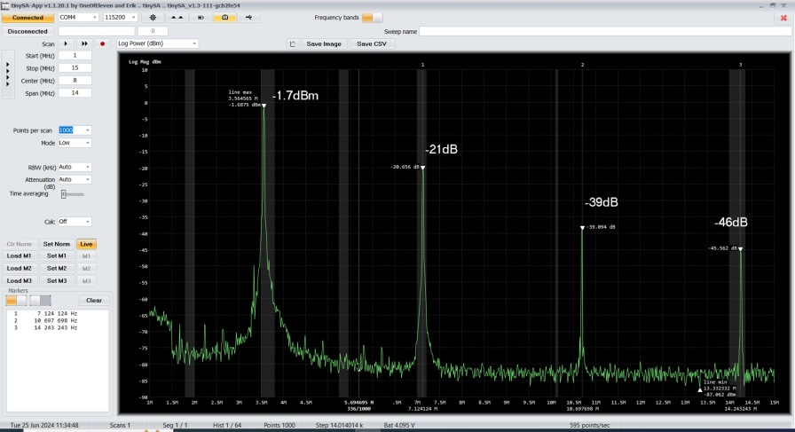  
80m bez C23  
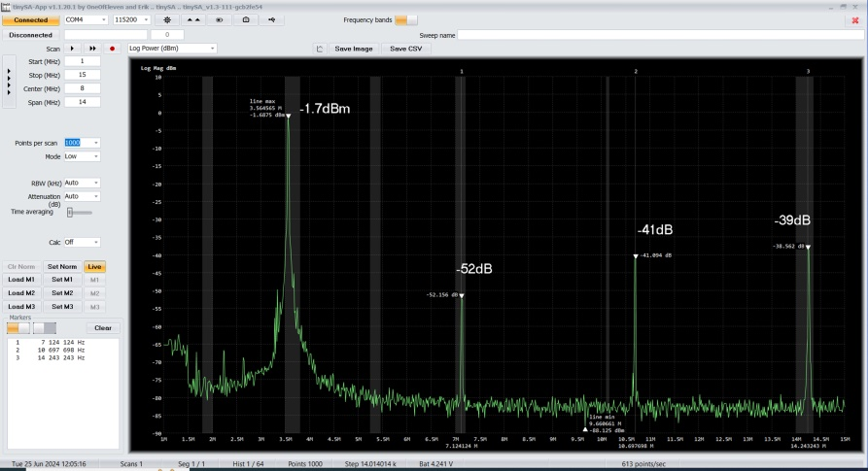  
80m s C23

**60m + 80m\***C16, C17 75pF, L1 15uH, C12, C15 680pF, L4 1.5uH, C23 100pF, L2.L3 150uH, R9 220R, R11 270R  
60m odber 200mA, Vpp 13.6V, excelentni potlaceni harmonickych  
80m odber 250mA, Vpp 17.7V, spatne potlaceni 2. Harmonicke

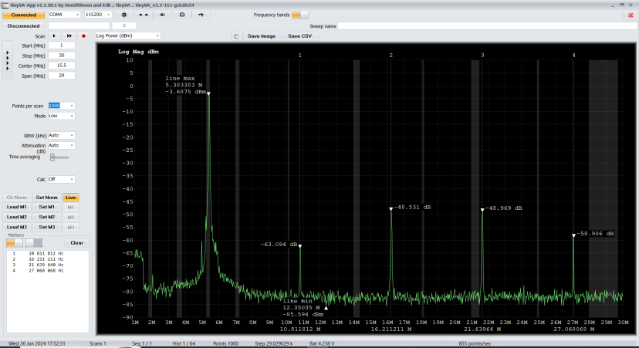  
Potlaceni harmonickych jen na 60m  
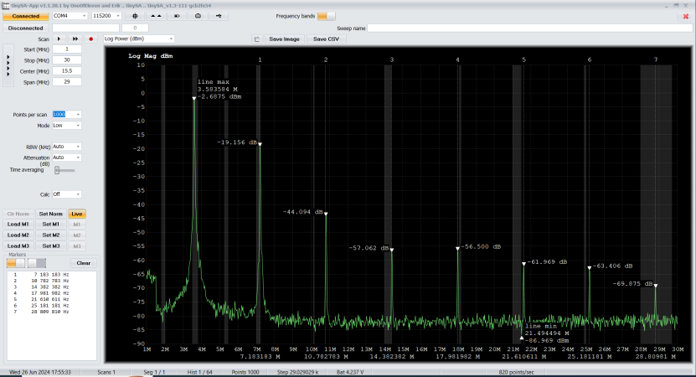  
Mizerne potlaceni 2.harmonicke pro 80m na 60m PA LPF

**40m + 60m\***C16, C17 47pF, L1 10uH, C12, C15 680pF, L4 1.0uH, L2, L3 47uH, R9 220R, R11 390R  
C23 245pF optimum pro 40+60m  
C23 170pF pro minimum 2. harmonicke jen pro 7MHz  
60m 14.9 Vpp, odber 240mA  
40m 14 Vpp(7.0MHz), 13.6Vpp(7.2MHz), odber 200mA  
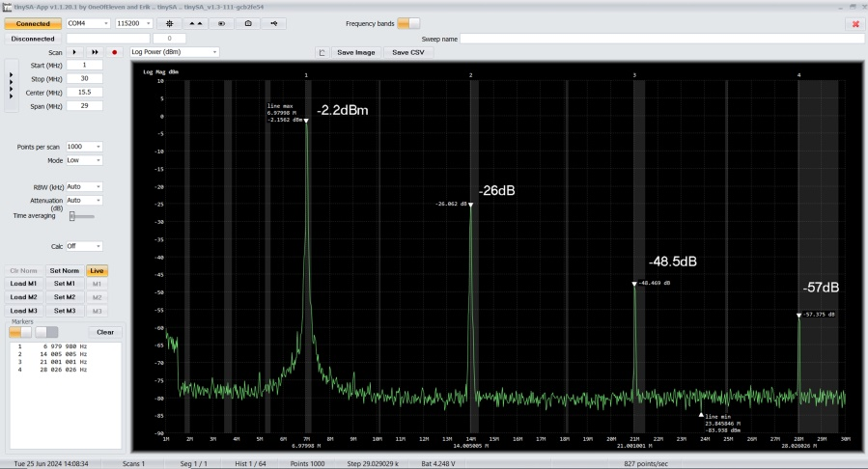  
40m bez C23

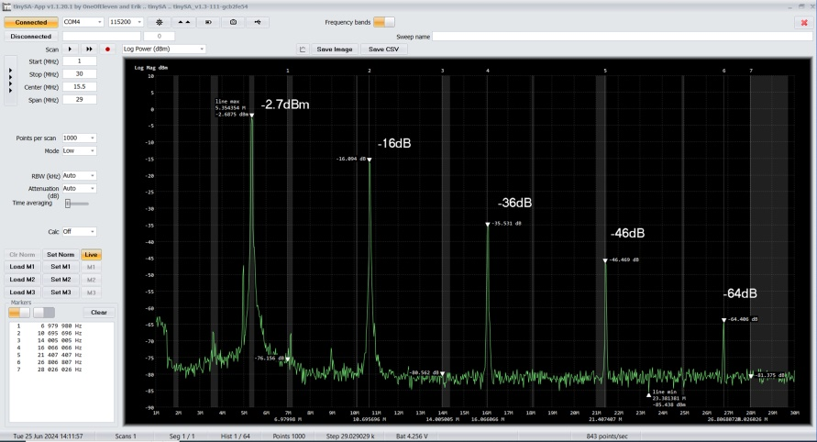  
60m na 40m LPF bez C23  
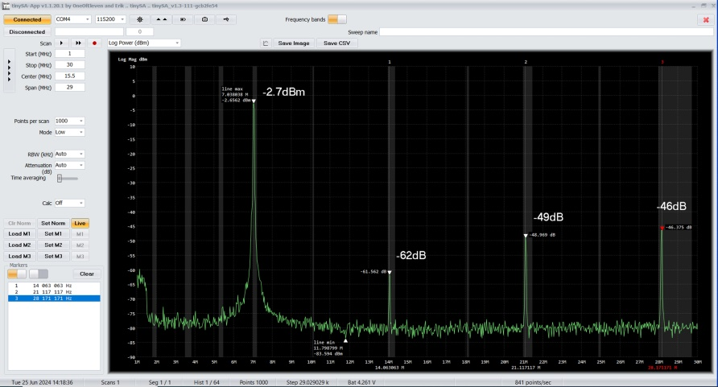  
40m optimalni C23  
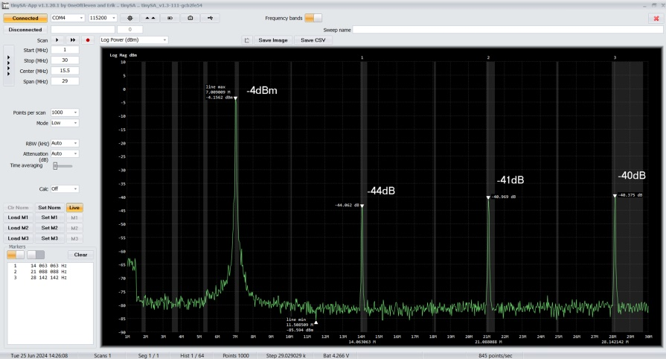  
40m kompromisni C23 i pro 60m  
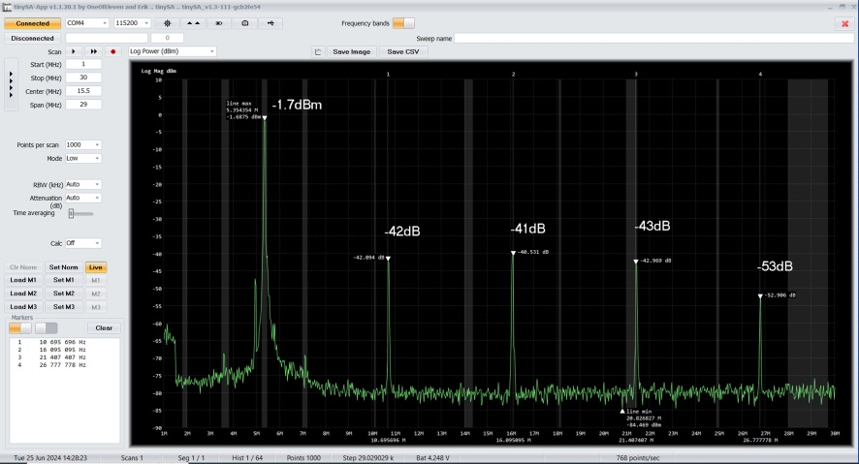  
60m na 40m LPF kompromisni C23

**30m + 40m\***C16, C17 62pF, L1 5.6uH, C12, C15 330pF, L4 712nH, C23 87pF, L2, L3 47uH, R9 220R, R11 100R

**20m + 30m\***C16, C17 43pF, L1 3.3uH, C12, C15 220pF, L4 470nH, C23 87pF, L2, L3 22uH, R9 220R, R11 100R  
20m odber 190mA Vpp 12.5V  
30m odber 220mA Vpp 13.8V  
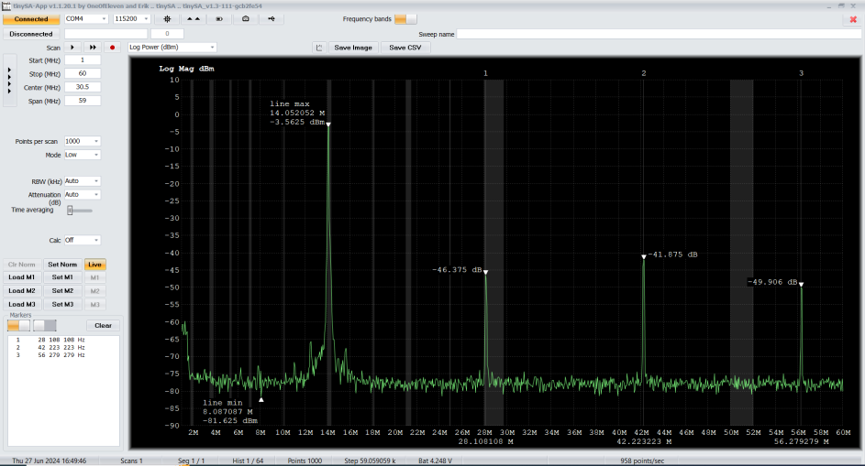  
20m s C23 kompromis, nezbytny C24 – kmita na 150MHz  
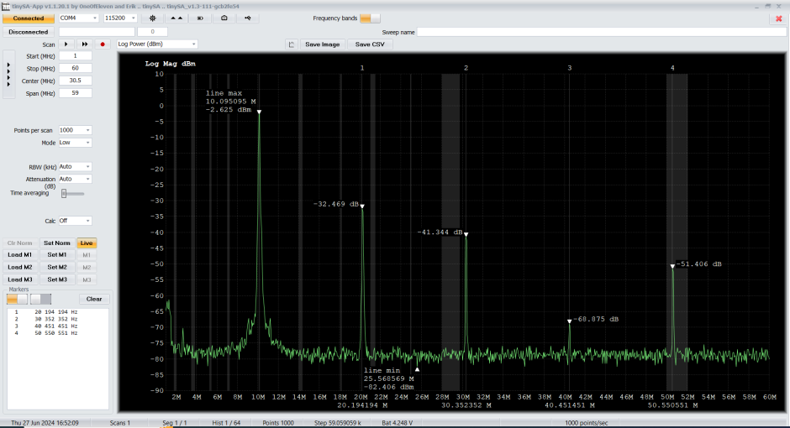  
30m na 20m LPF s C23 kompromis